**USE CASE DIAGRAM**

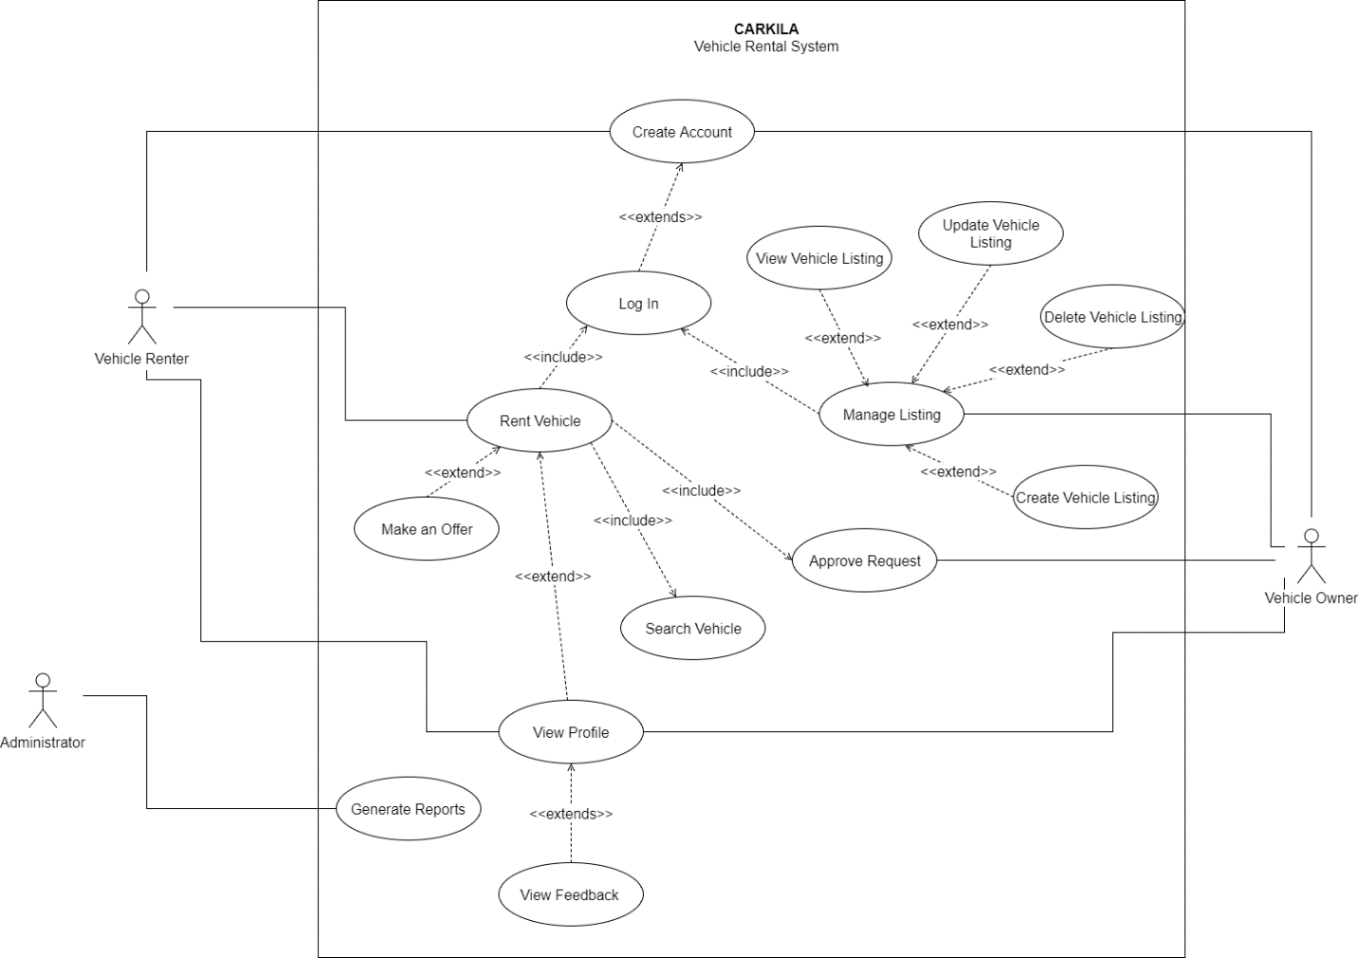

USE CASE FULL DESCRIPTION

|  |  |  |
| --- | --- | --- |
| **Use Case Name:** | Create Account | |
| **Scenario:** | User wants to create an account. | |
| **Triggering Event:** | New account request | |
| **Brief Description:** | This will allow the user to create an account. | |
| **Actors:** | Vehicle owner, vehicle renter | |
| **Related Use Case:** | Log In | |
| **Stakeholders:** | Vehicle owner, vehicle renter | |
| **Preconditions:** | The user must have the mobile application installed. | |
| **Post conditions:** | The user must be able to access the app features. | |
| **Flow of Activities:** | **Actor** | **System** |
| 1. The user opens the mobile application. 2. The user taps **Create Account**. 3. The user enters the required information. 4. The user enters the verification code. | * 1. The system displays the create account/log in page.   2. The system prompts the user to enter the required information.   3.1 The system validates the data entered.  3.2 The system sends a verification code and displays the verification page.  4.1 The system validates the verification code.  4.2 The system stores all the data entered.  4.3 The system directs the user to the home page. |
| **Exception Conditions:** | If the user entered invalid data.  If the user entered invalid verification code.  If the user cancels the creation of account. | |

|  |  |  |
| --- | --- | --- |
| **Use Case Name:** | Rent Vehicle | |
| **Scenario:** | Vehicle renter wants to rent a vehicle. | |
| **Triggering Event:** | Request a vehicle | |
| **Brief Description:** | This will allow the user to rent a vehicle. | |
| **Actors:** | Vehicle renter | |
| **Related Use Case:** | Create Account | |
| **Stakeholders:** | Vehicle renter | |
| **Preconditions:** | The vehicle renter must be logged in. | |
| **Post conditions:** | The vehicle must be able to book a vehicle.  A notification must be sent to the vehicle owner. | |
| **Assumptions:** | The vehicle renter is already logged in. | |
| **Flow of Activities:** | **Actor** | **System** |
| 1. The renter taps on **Browse Vehicles.** 2. The renter clicks on a vehicle listing. 3. The renter clicks **Book Now**. 4. The renter enters the trip details. 5. The renter clicks **Make an Offer**. 6. The renter enters desired price. 7. Click **Send Request**. | * 1. The system displays the list of vehicles.   2.1 The system displays the vehicle information page.  3.1 The system prompts the renter to enter trip details.  5.1 The system prompts user to enter price offer.  6.1 The system redirects back to trip details page.  7.1 The system sends a rent request notification to the vehicle owner. |
| **Exception Conditions:** | * 1. If the renter wants to check the profile of owner, initiate *View Profile* use case. | |

|  |  |  |
| --- | --- | --- |
| **Use Case Name:** | Manage Listing | |
| **Scenario:** | Vehicle owner wants to list his vehicle. | |
| **Triggering Event:** | Request to manage listing | |
| **Brief Description:** | This will allow the vehicle owner to create, view, update, or delete a vehicle listing. | |
| **Actors:** | Vehicle owner | |
| **Related Use Case:** | Create Account | |
| **Stakeholders:** | Vehicle owner | |
| **Preconditions:** | The vehicle owner must be logged in. | |
| **Post conditions:** | The listing must be published in the mobile application. | |
| **Assumptions:** | The vehicle owner is already logged in. | |
| **Flow of Activities:** | **Actor** | **System** |
| 1. The vehicle owner taps onthe **Listing** tab**.**   2.A. The vehicle owner taps **Create Vehicle Listing.**  3. The vehicle owner enters all required information. | * 1. The system displays the listing page.   2.A.1. The system prompts the user to enter required vehicle information and upload required documents.  3.1 The system will store the information and publish the vehicle listing in the app. |
| **Exception Conditions:** | 2.B. If the vehicle owner wants to view, the system displays the vehicle listing details.  2.C. If the vehicle owner wants to edit the listing, the system displays the listing in edit mode.  2.D. If the vehicle owner wants to delete an existing listing, The system removes the listing from the app. | |

|  |  |  |
| --- | --- | --- |
| **Use Case Name:** | Approve Request | |
| **Scenario:** | Vehicle owner wants to accept a rent request. | |
| **Triggering Event:** | Request to manage listing | |
| **Brief Description:** | This will allow the vehicle owner to accept a rent request. | |
| **Actors:** | Vehicle owner | |
| **Related Use Case:** | Create Account, Rent Vehicle | |
| **Stakeholders:** | Vehicle owner | |
| **Preconditions:** | The vehicle owner must be logged in.  The vehicle owner must receive a rent request notification. | |
| **Post conditions:** | The vehicle renter must receive a rent request. | |
| **Assumptions:** | The vehicle owner is already logged in. | |
| **Flow of Activities:** | **Actor** | **System** |
| 1. The vehicle owner taps on **Notifications**. 2. The vehicle renter taps on a request. 3. The vehicle renter taps **Accept.** | * 1. The system displays the notification page.   2.1 The system displays the trip details sent by the renter.  3.1 The systems notifies the renter that the rent request has been accepted. |
| **Exception Conditions:** | 2.2. If the vehicle owner wants to view profile, initiate *View Profile* use case.  3.2 If the vehicle owner declines the request, the system notifies the vehicle renter that the rent request had been declined. | |

|  |  |  |
| --- | --- | --- |
| **Use Case Name:** | View Profile | |
| **Scenario:** | The vehicle renter wants to view the profile of the vehicle owner. | |
| **Triggering Event:** | Profile request | |
| **Brief Description:** | This will allow the vehicle renter to view the profile of the vehicle owner or vice versa. | |
| **Actors:** | Vehicle renter | |
| **Related Use Case:** | Rent a Vehicle | |
| **Stakeholders:** | Vehicle renter | |
| **Preconditions:** | The vehicle renter must select a vehicle listing. | |
| **Post conditions:** | The vehicle renter must be able to see the vehicle owner’s profile. | |
| **Assumptions:** | The vehicle renter is already logged in.  The vehicle renter is already on a vehicle listing page. | |
| **Flow of Activities:** | **Actor** | **System** |
| 1. The vehicle renter clicks on the icon of the vehicle owner. | 1.1 The system displays the vehicle information.  2.1 The system displays the profile of the owner. |
| **Exception Conditions:** | 2. If the vehicle renter wants to view the feedbacks on the owner, initiate *View Feedback* use case. | |

|  |  |  |
| --- | --- | --- |
| **Use Case Name:** | View Feedback | |
| **Scenario:** | The vehicle renter wants to view the feedbacks on the owner. | |
| **Triggering Event:** | View user feedback | |
| **Brief Description:** | This will allow the vehicle renter to view the feedbacks on the owner or vice versa. | |
| **Actors:** | Vehicle renter | |
| **Related Use Case:** | View Profile | |
| **Stakeholders:** | Vehicle renter | |
| **Preconditions:** | The vehicle renter must select a vehicle listing. | |
| **Post conditions:** | The vehicle renter must be able to see the feedbacks. | |
| **Assumptions:** | The vehicle renter is already on the profile of the vehicle owner. | |
| **Flow of Activities:** | **Actor** | **System** |
| 1. The vehicle renter taps **Feedbacks.** | 1.1 The system displays the feedback catalog. |
| **Exception Conditions:** | - | |

|  |  |  |
| --- | --- | --- |
| **Use Case Name:** | Generate Reports | |
| **Scenario:** | The admin requests the system to generate reports. | |
| **Triggering Event:** | Report request | |
| **Brief Description:** | This will allow the administrator to generate a report. | |
| **Actors:** | Administrator | |
| **Related Use Case:** |  | |
| **Stakeholders:** | Administrator | |
| **Preconditions:** | There must be existing bookings. | |
| **Post conditions:** | A report must be created.  The report must be stored in the database. | |
| **Flow of Activities:** | **Actor** | **System** |
| 1. The admin wants to generate a report**.** 2. The admin receives the report. | * 1. The system retrieves data from the database.   2. The system analyzes the data.   3. The system displays the generated report.   4. The system stores the report in the database. |
| **Exception Conditions:** | If there is no existing booking. | |

**CLASS DIAGRAM**

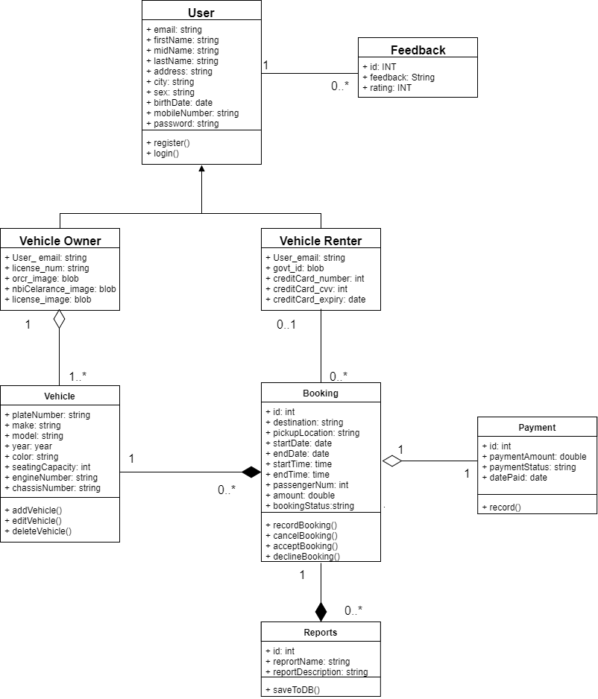

**OBJECT DIAGRAM**

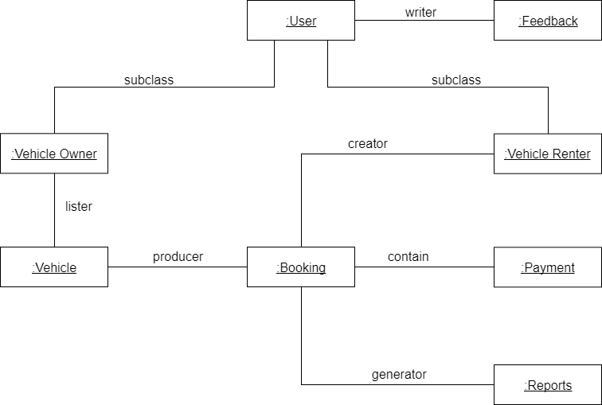

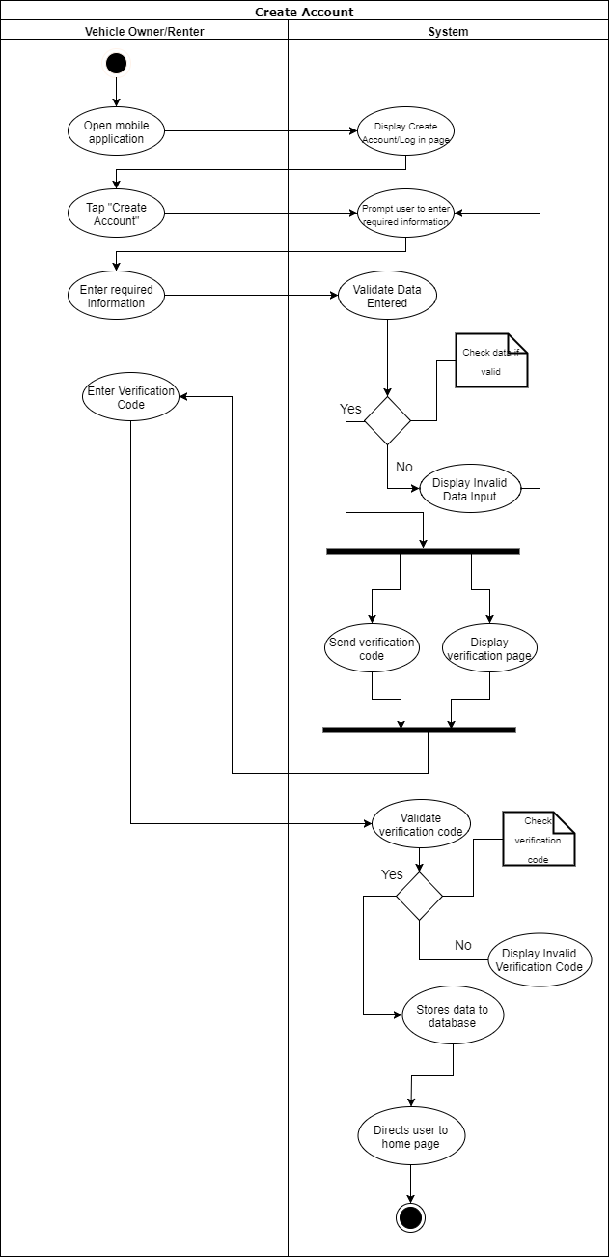**ACTIVITY DIAGRAM**

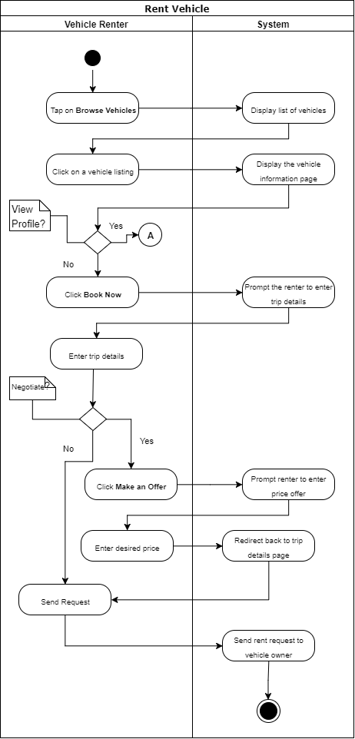

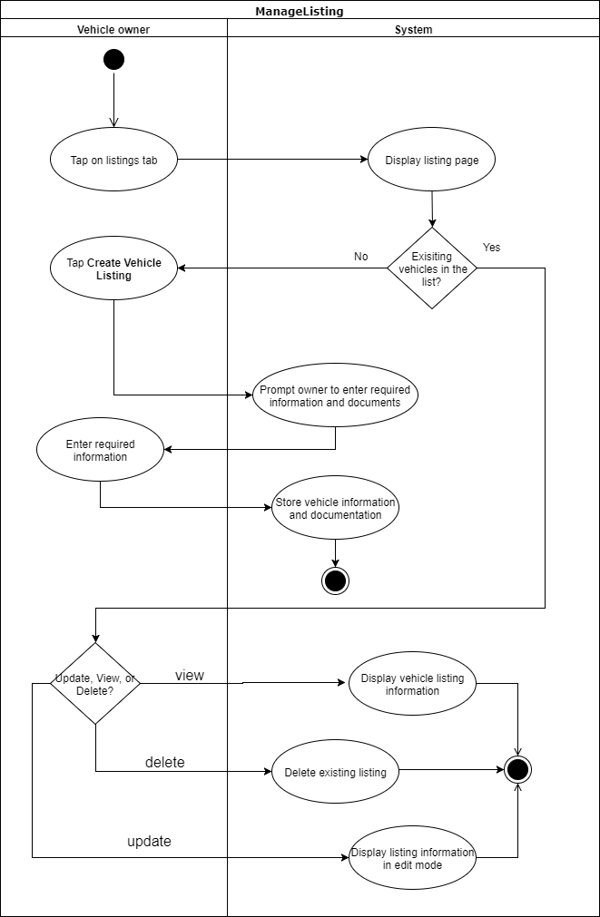

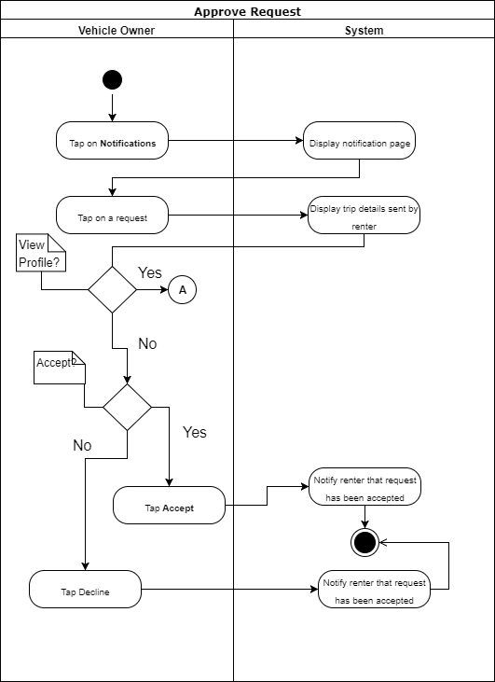

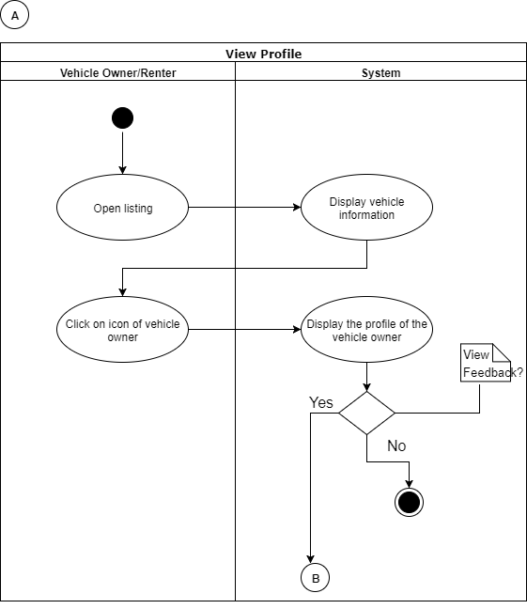

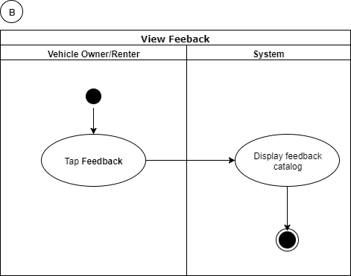

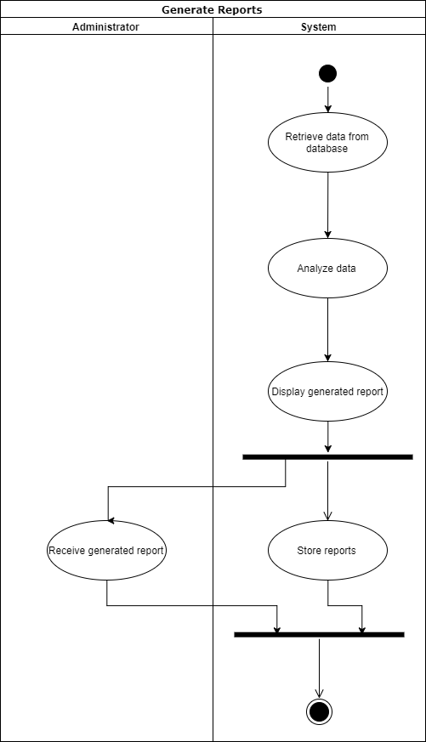

**SEQUENCE DIAGRAM**

Create Acocunt

Rent Vehicle

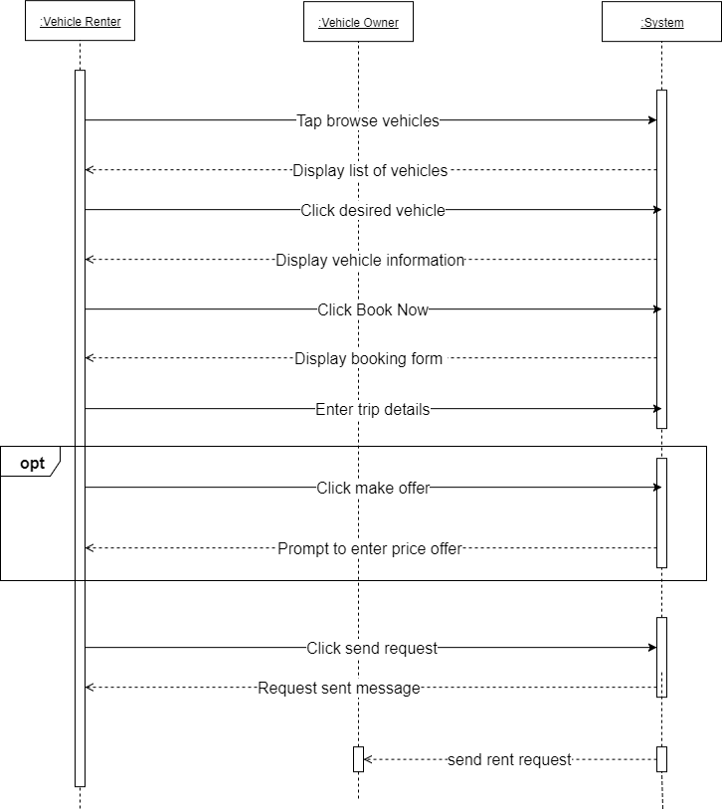

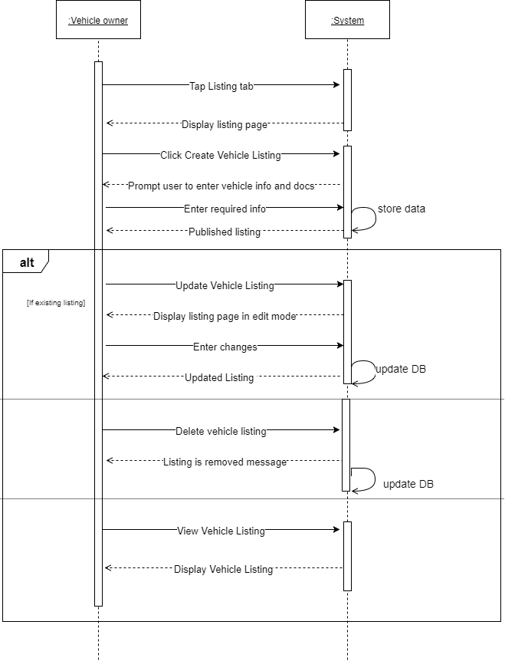Manage Listing

Approve Request

View Profile

View Feedback

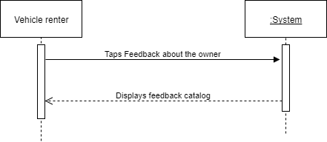

**STATE DIAGRAM**

**TIMING DIAGRAM**

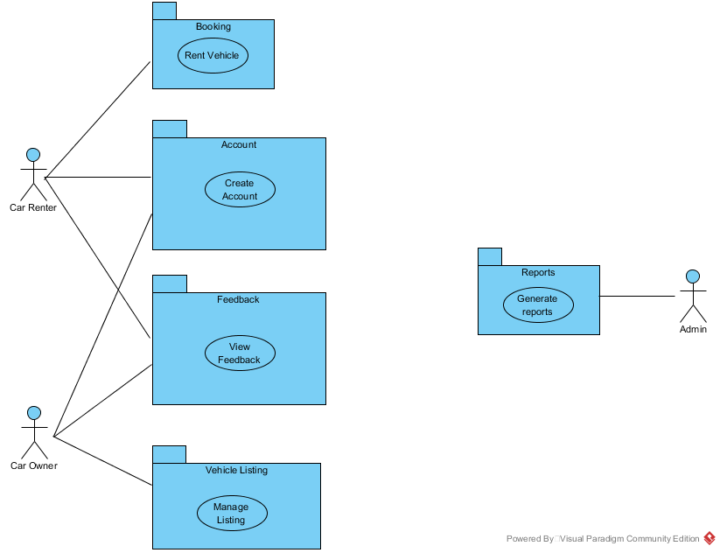**PACKAGE DIAGRAM**

**COMMUNICATION DIAGRAM**

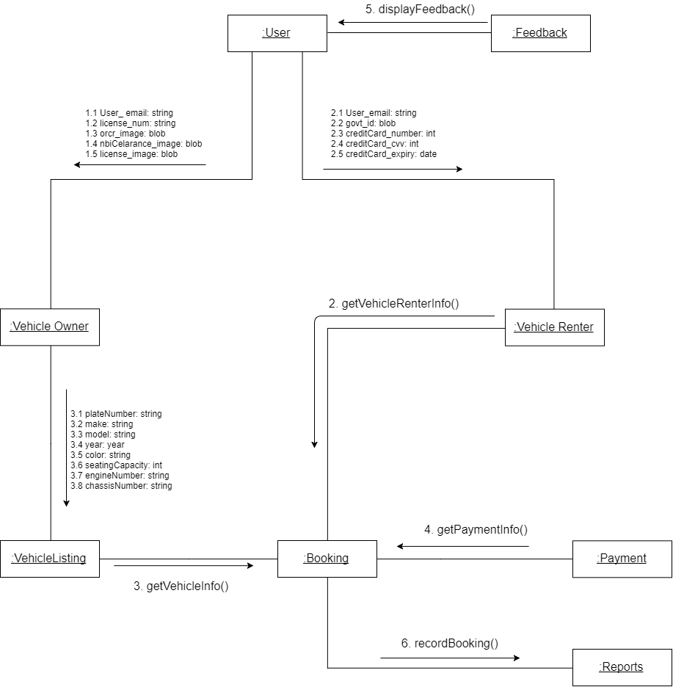

**COMPONENT DIAGRAM**

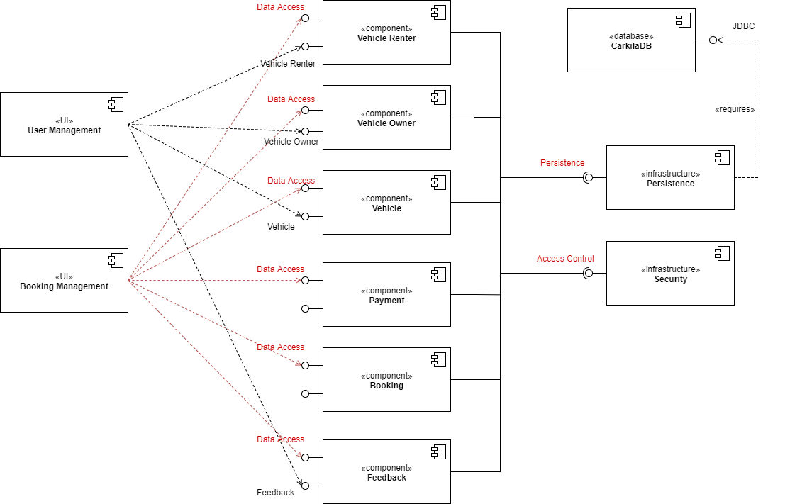

**DEPLOYMENT DIAGRAM**

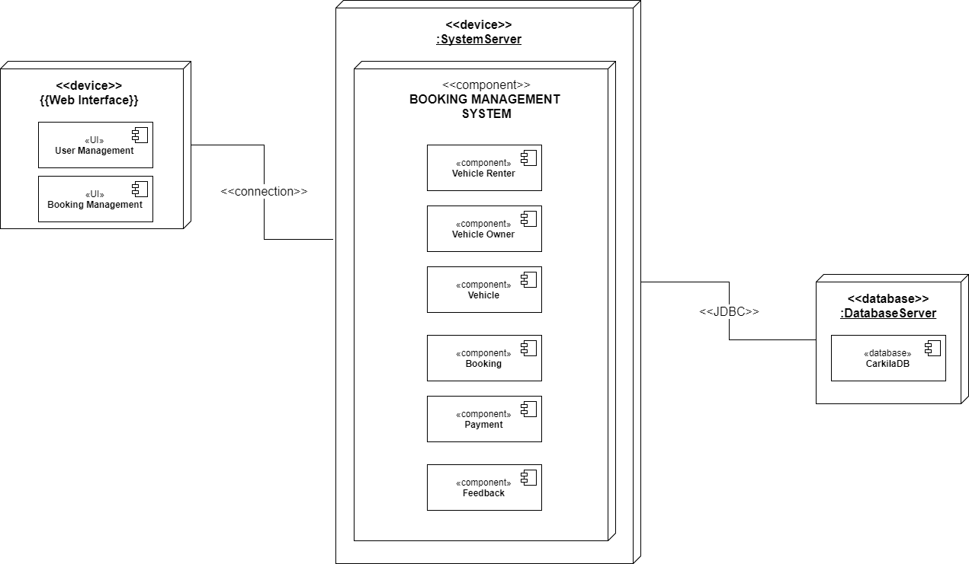

**COMPOSITE STRUCTURE DIAGRAM**